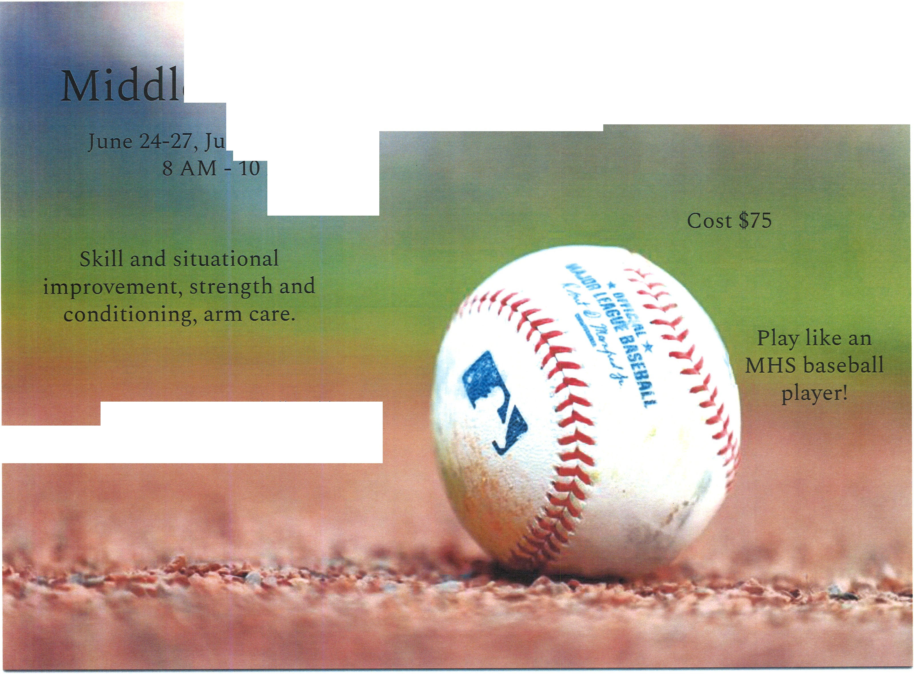
e School Skills Camp Multi Week camp.

ly 1-2, July 8-11
;i.,<:·
AM

Location: MHS Baseball Field. MHS Fieldhouse in case of rain.

To confirm registration scan this completed form to tschmitt@mcpasd.k12.wi.us or mail the form to Tom Schmitt at PO Box 620823 Middleton, WI 53562-0823

Checks can be made out to "Middleton Cardinal Dugout Club" and sent to the above address.

I hereby give my permission for (please print) to attend the Cardinal baseball clinic. I agree that in the event of injury or illness, the coaching staff and Commission shall not be held responsible. I also give my permission for the staff to administer first-aid if necessary. Each participant will be responsible for his/her own insurance.

Parent/Guardian Signature _ Date--------

